Chapter 6, Problem 42.

If the voltage waveform in Fig. 6.67 is applied across the terminals of a 5-H inductor, calculate the current through the inductor. Assume i(0) = –1 A.

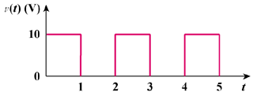

Figure 6.67
For Prob. 6.42.

